JAVASCRIPT

1.

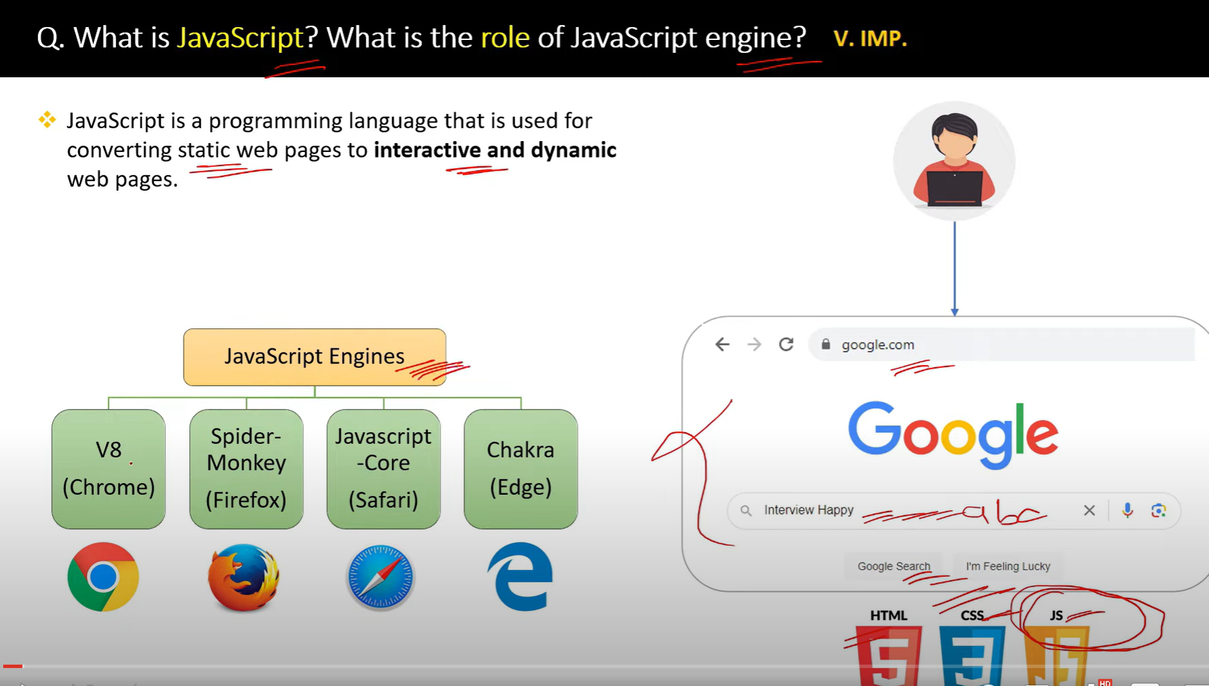

**JavaScript (JS)** is a high-level, dynamic, and interpreted programming language that is widely used to create interactive, dynamic content for websites. Originally developed to enable client-side scripting in web browsers, JavaScript has grown into a versatile language used in various environments, including web servers, mobile apps, desktop applications, and more.

**Key Characteristics of JavaScript:**

1. **Interpreted Language**:
   * JavaScript code is executed line by line by the browser's JavaScript engine, without needing to be compiled.
2. **Client-Side Scripting**:
   * JavaScript primarily runs in the browser to enhance user interaction. It allows developers to manipulate web content, handle events, validate user input, and create interactive websites.
3. **Event-Driven**:
   * JavaScript allows handling events such as user clicks, form submissions, or keyboard inputs, making websites responsive and interactive.
4. **Lightweight and Fast**:
   * JavaScript is lightweight and designed to work quickly, providing instant responses to user actions.
5. **Dynamic Typing**:
   * Variables in JavaScript are not explicitly typed. The same variable can hold different types of values at different times (e.g., numbers, strings, or objects).
6. **Object-Oriented Programming (OOP)**:
   * While JavaScript uses prototypes instead of traditional class-based inheritance, it still supports object-oriented programming principles like encapsulation, inheritance, and polymorphism.
7. **Multi-paradigm**:
   * JavaScript supports various programming paradigms, including imperative (procedural), object-oriented, and functional programming.
8. **Runs Everywhere**:
   * JavaScript can be used both on the client side (in the browser) and on the server side (with

2.

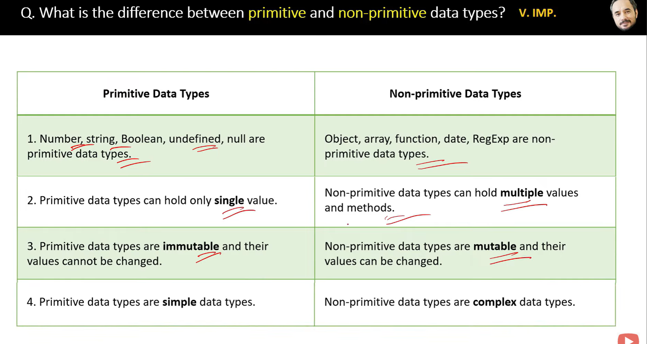

A **mutable** object or variable can be modified after it is created.

An **immutable** object or variable cannot be modified after it is created.

3.

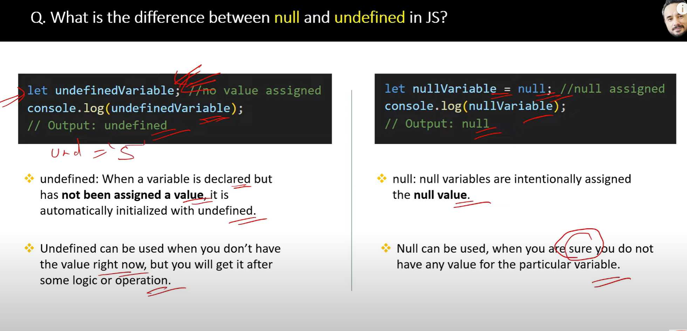

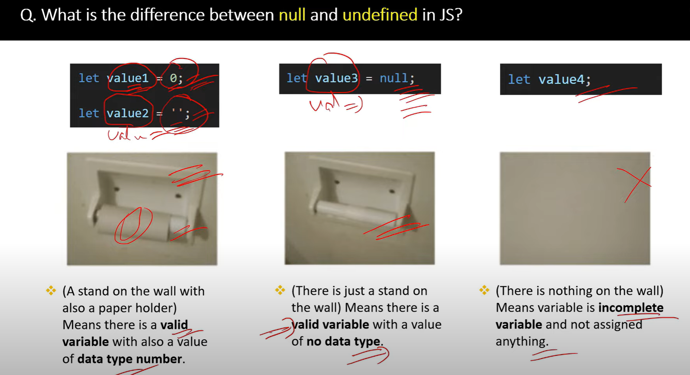

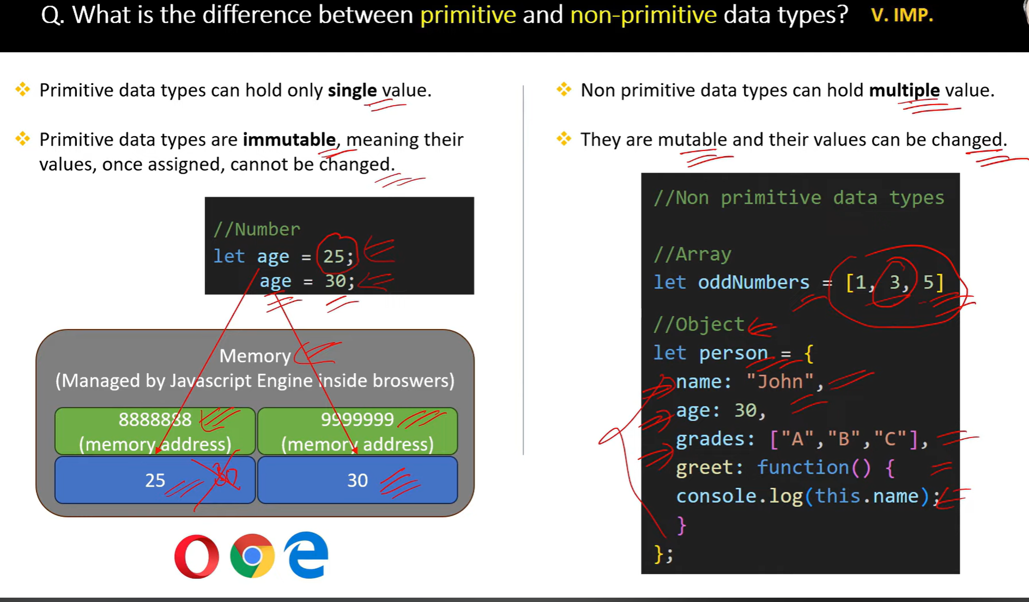

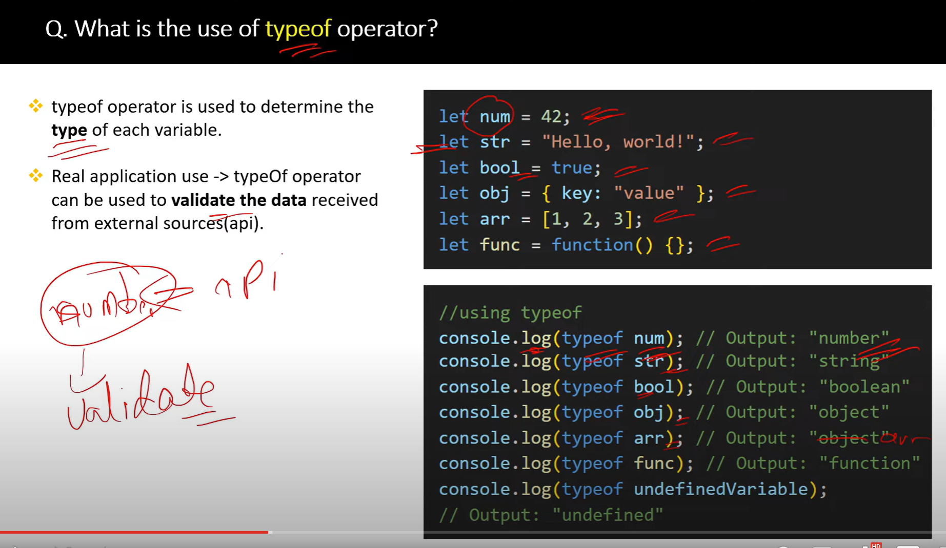

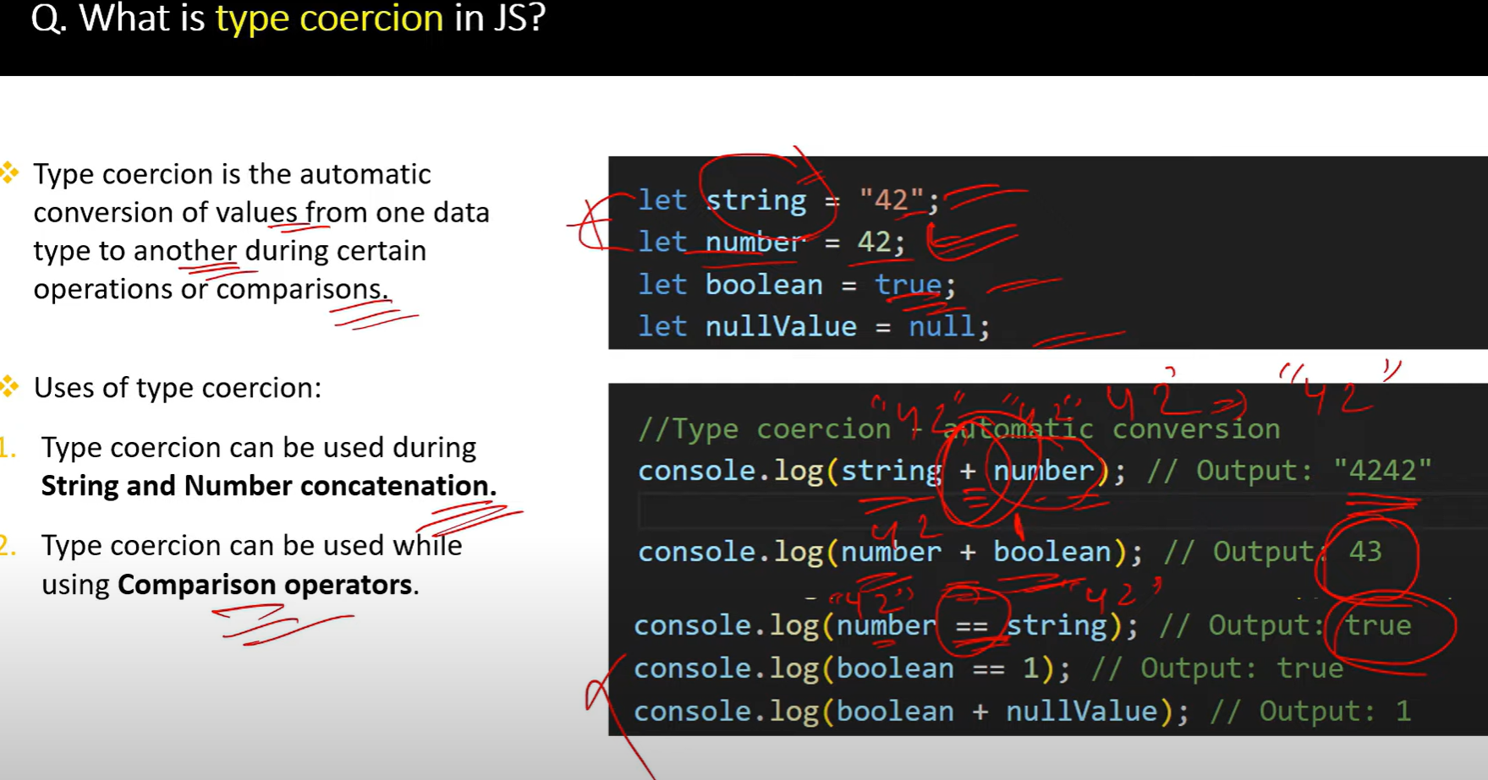

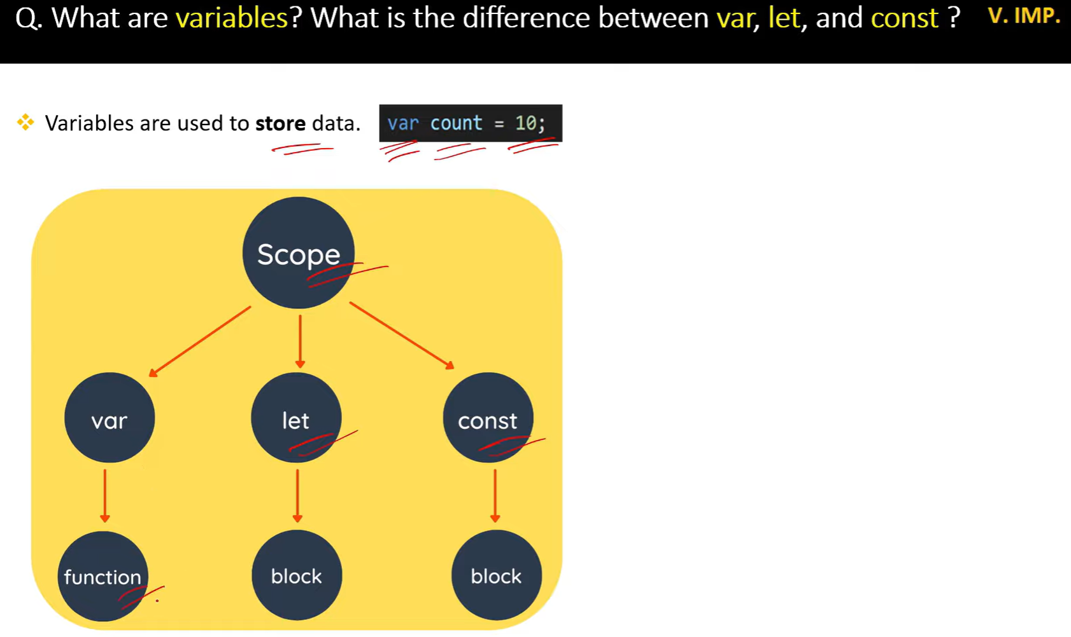

//===========================scope ========================

var  // functional scope

let and const //block scope

// global scope

let b= 10

function Test (){

    var a= 5

    console.log(a) // 5x

    console.log(b) // 10

}

console.log(a)  //a is not defined

// block scope

{

 var a =5;

 const b =10;

    console.log(a) //5

    console.log(b) //10

}

console.log(a) //5

console.log(b) //b is not defined error

//====================variable shadowing=================

function Test(){

    let a= "Hello"

    if(true){

        let a="Hi"

        console.log(a) //Hi

    }

    console.log(a) //Hello

}

Test()

//=====================Illegal shadowing============

function test() {

    var a = "Hello";

    let b = "Bye";

    if (true) {

    let a = "Hi";

    var b = "Goodbye";

    console.log(a);   // Hi

    console.log(b);  //Identifier 'b' has already been declared

    }

    }

    test();

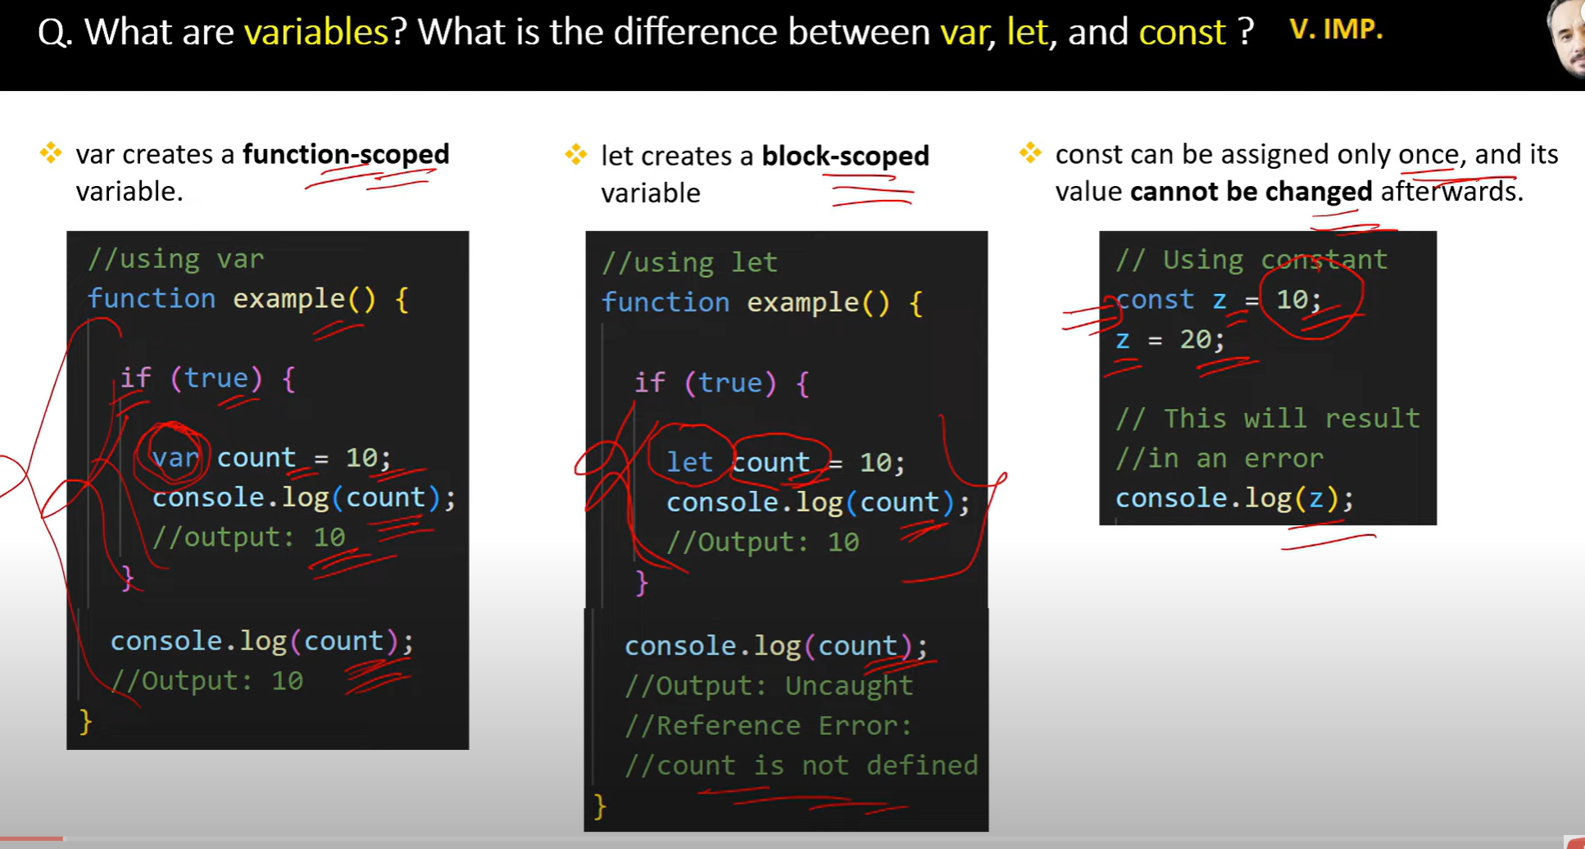

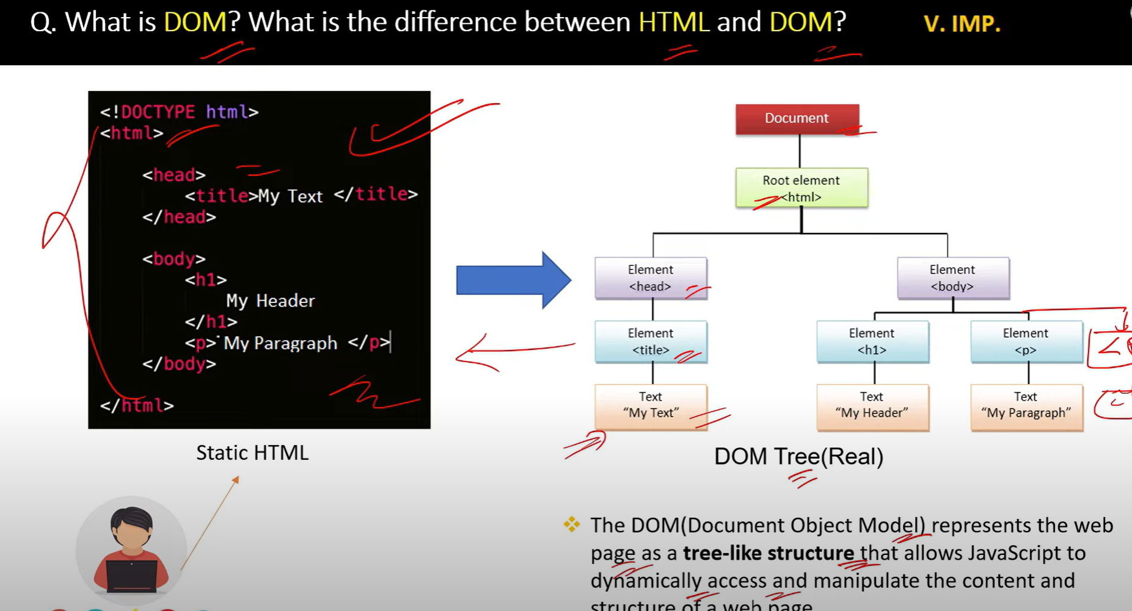

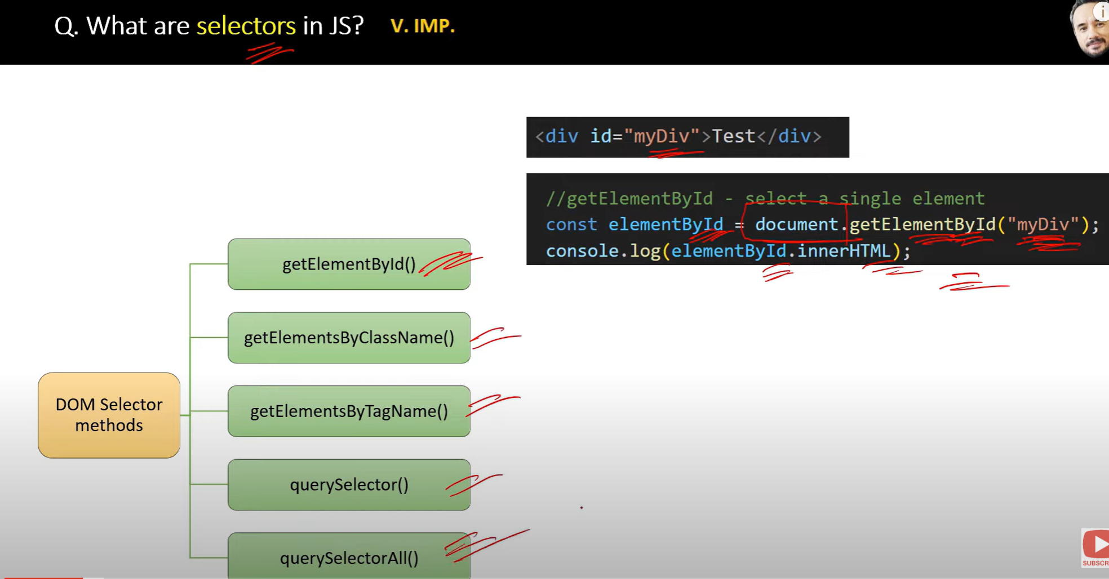

**selectors** refer to ways of selecting or accessing elements from the **Document Object Model (DOM)**, allowing developers to manipulate and interact with those elements

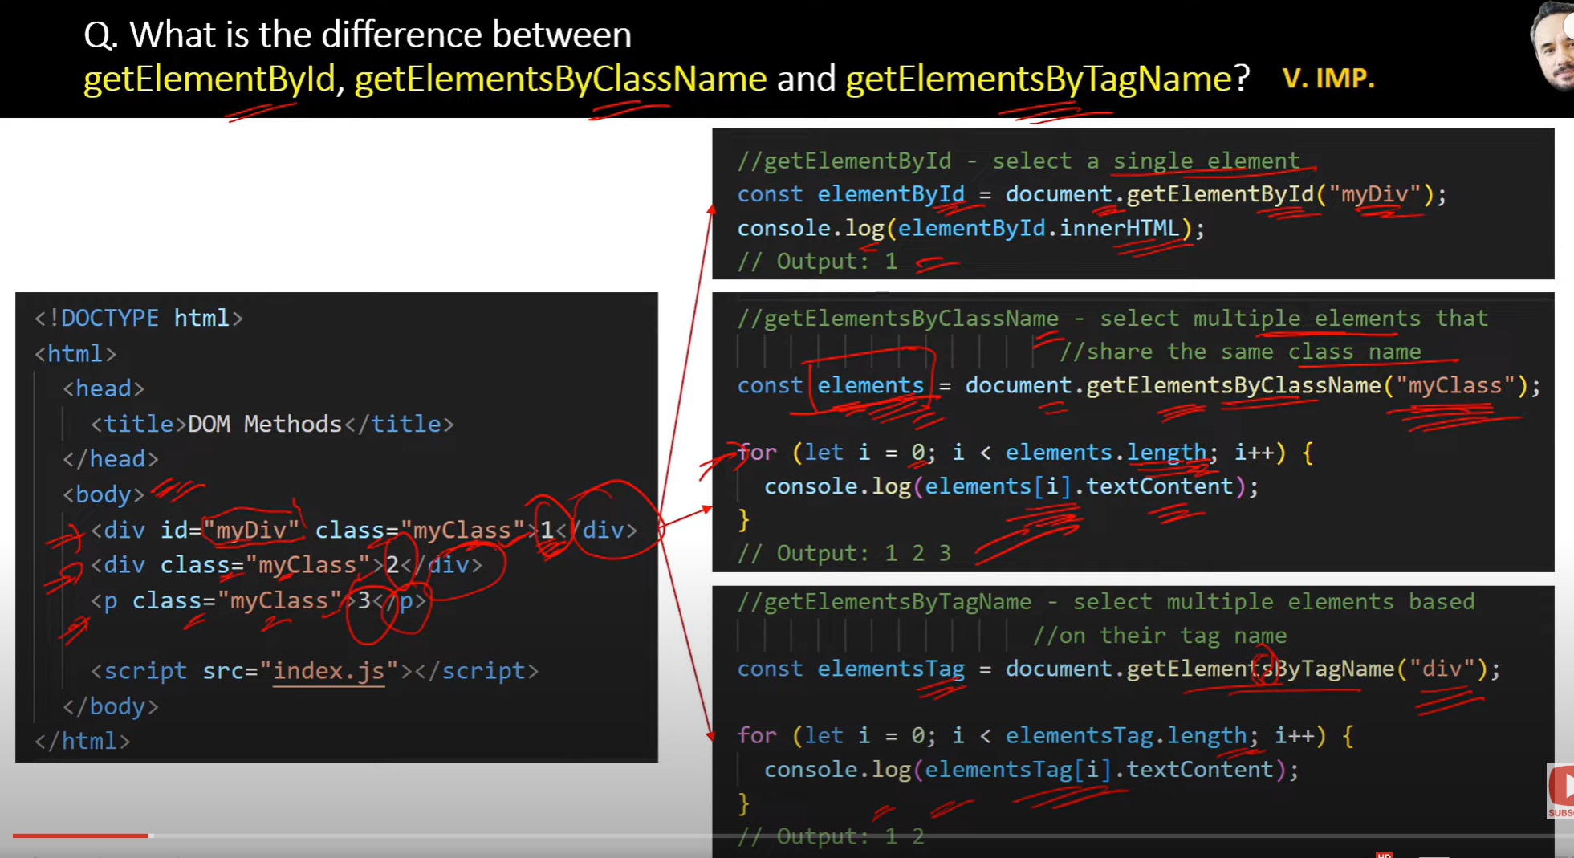

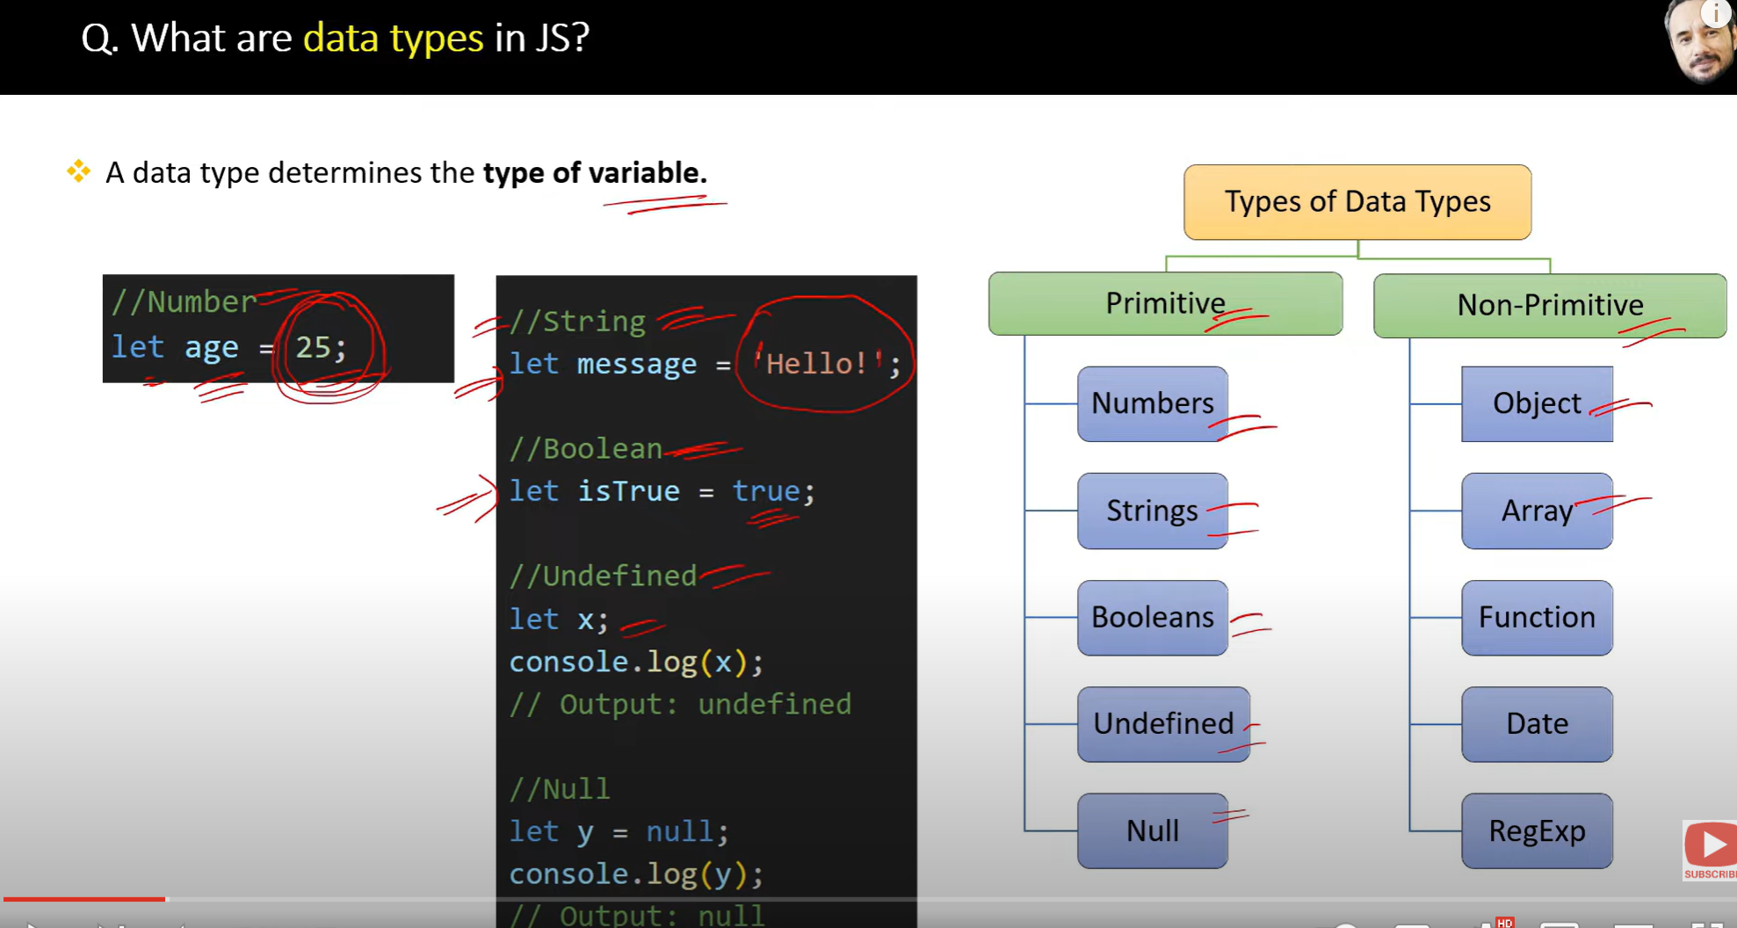

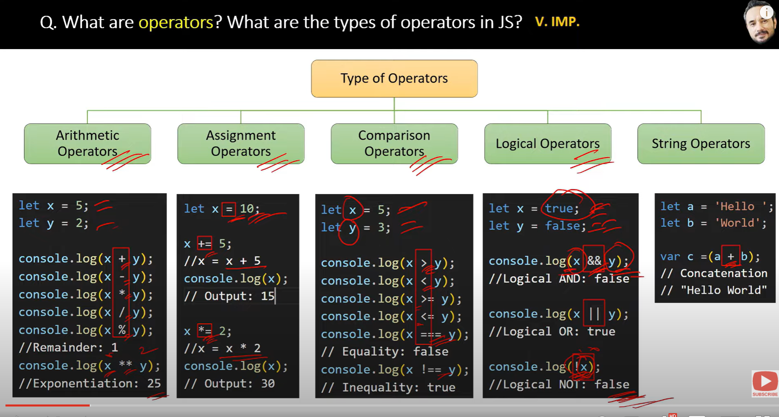

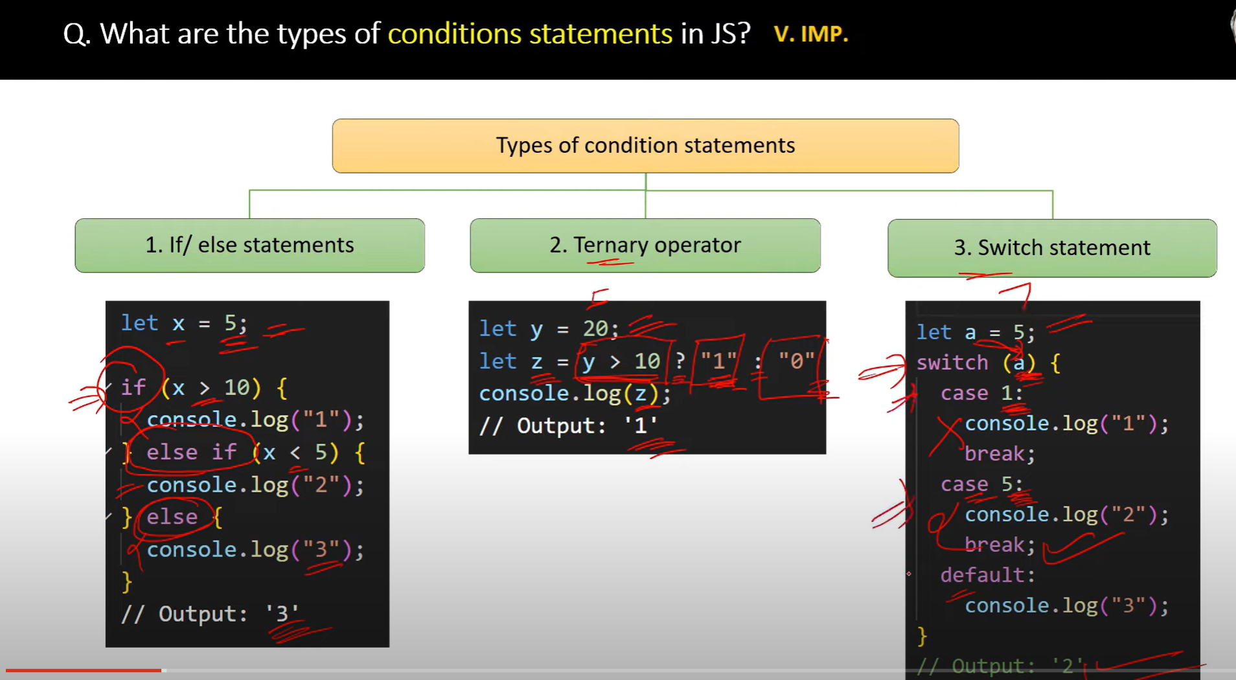

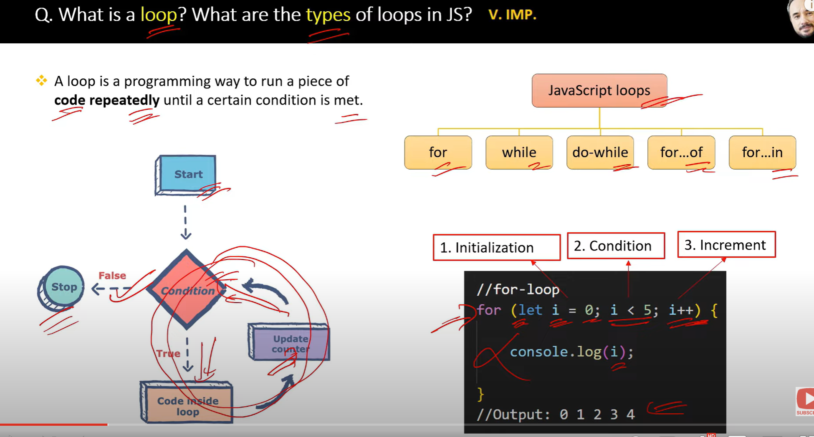

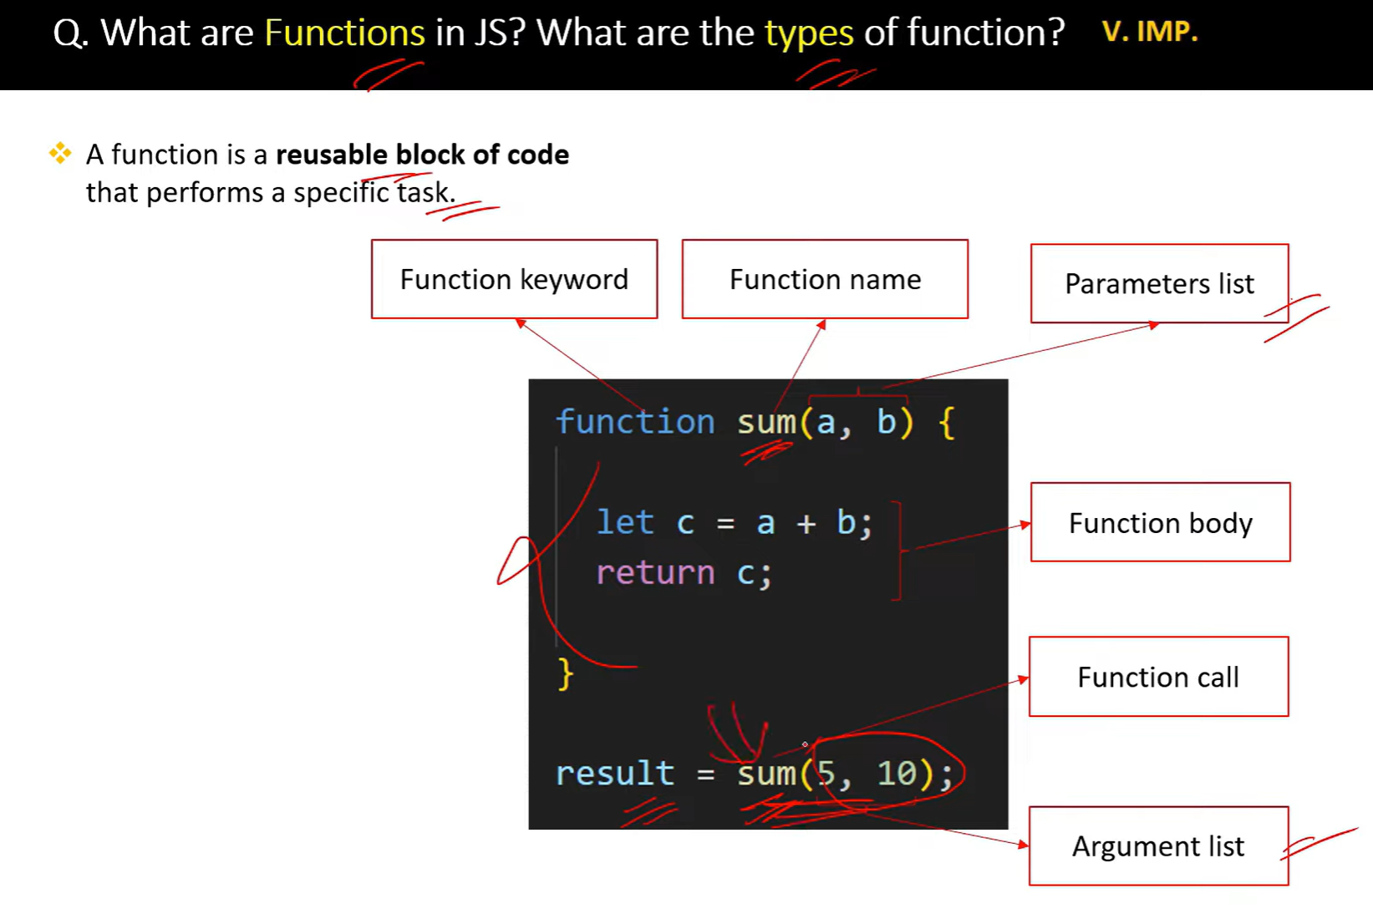

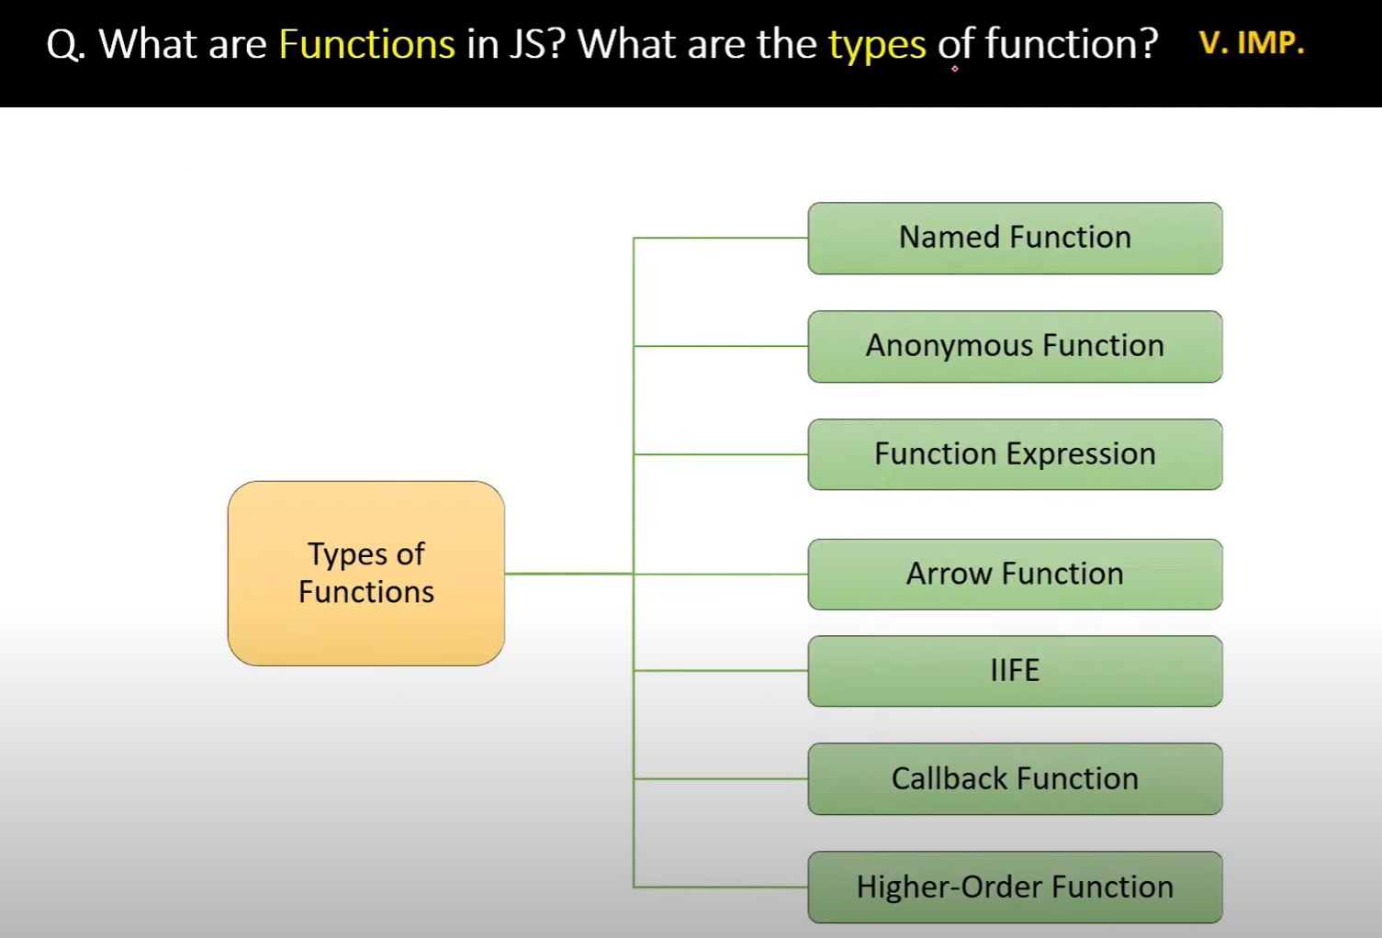

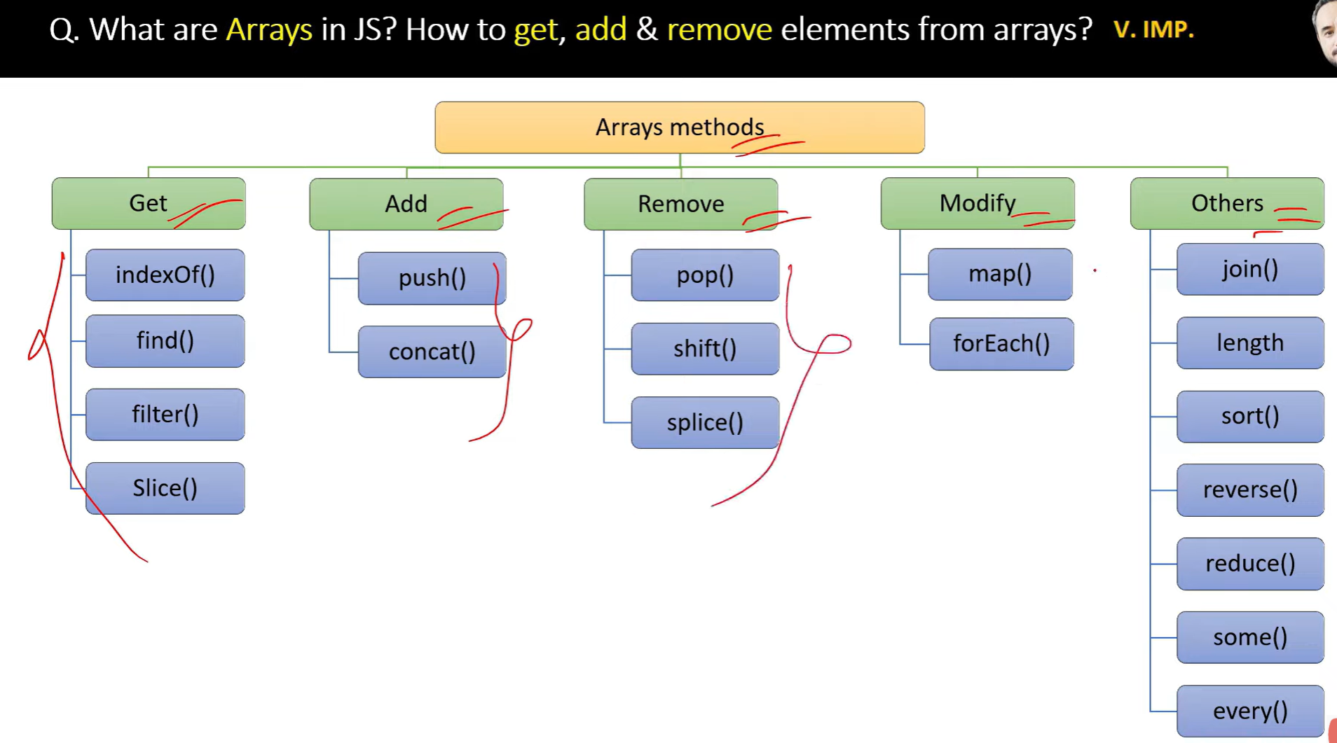

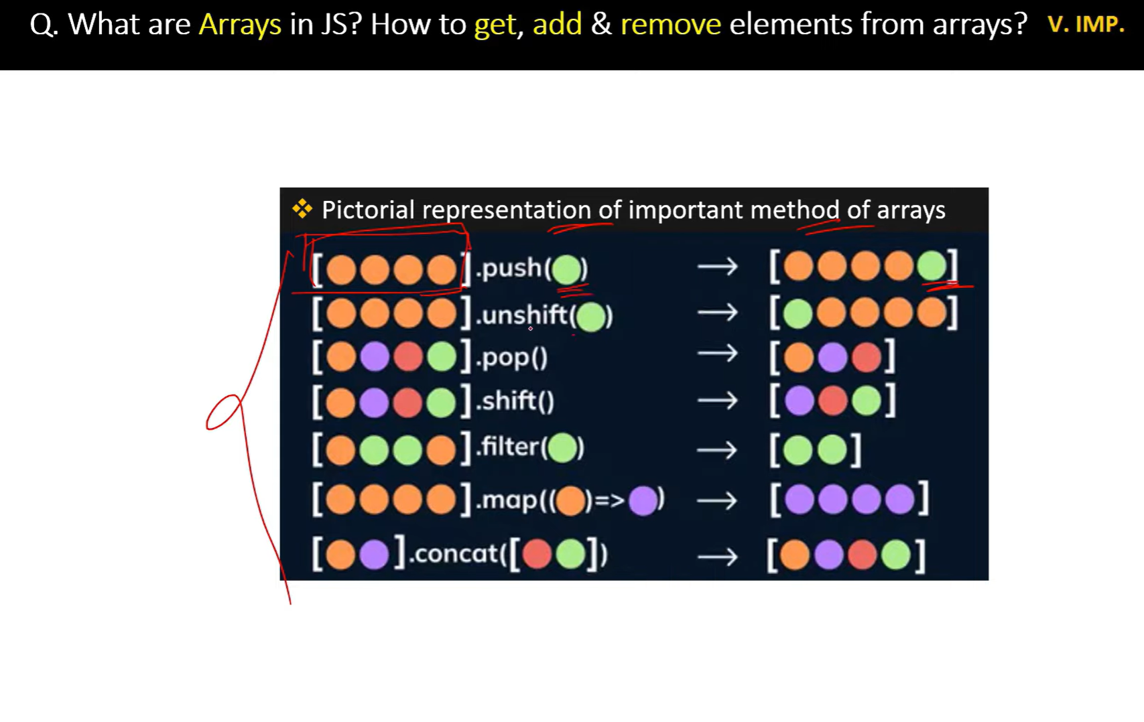

// map returns Array and also can chain with next method like filter, etc

// foreach doesnt return array but modifies the existing array.Also cannot chain

//=================Polifill of map====================

// creating own map function

Array.prototype.royMap= function(arr){

    let data=[];

    for(let i=0; i<this.length; i++){

        data.push(arr(this[i],i,this))

    }

    return data;

}

const mappedArray=[1,2,3].royMap((num,i,arr)=>{

    return num +3;

})

console.log(mappedArray)

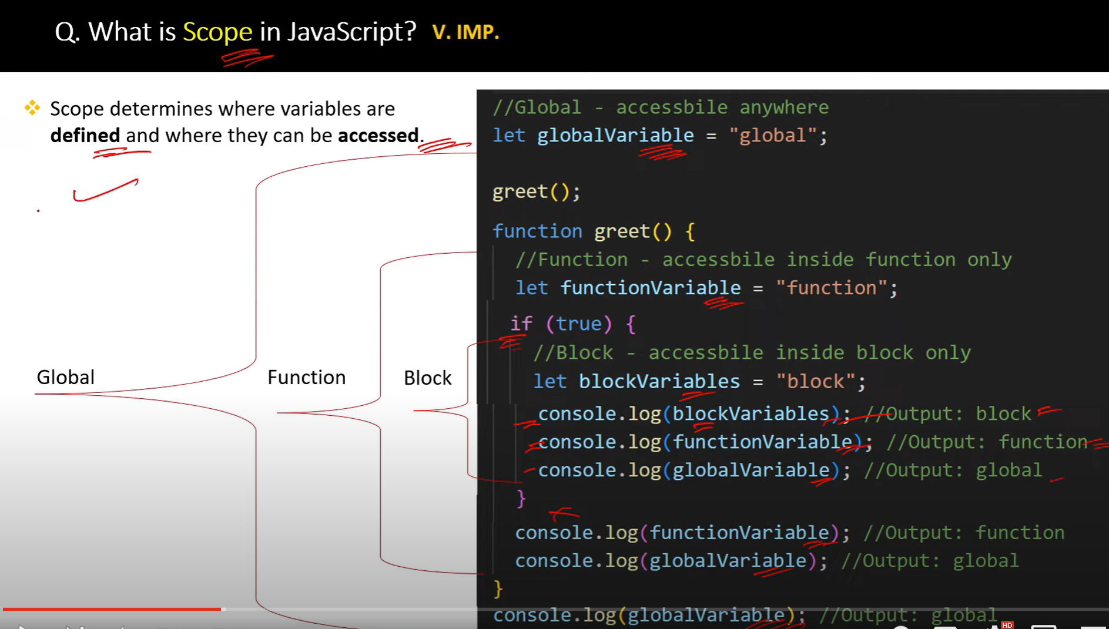

**closure** is a function that retains access to the variables from its **outer scope** even after the outer function has returned.

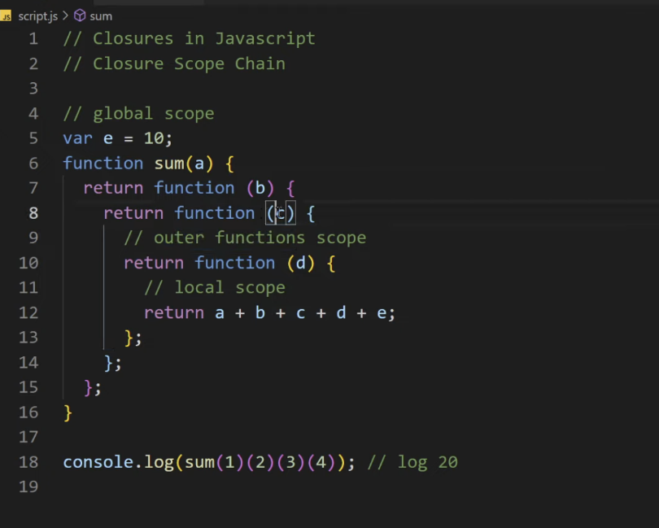

function outer() {

   let outerVar = "Hello";

   function inner() {

       console.log(outerVar);  // The inner function has access to `outerVar`

   }

   return inner;

}

const closureFunc = outer();  // outer() returns the inner function

closureFunc();  // Output: "Hello"

In this example:

* The inner() function is defined within the outer() function.
* Even though outer() finishes executing when it returns inner(), the returned closureFunc still has access to the variable outerVar from the outer() function’s scope. This happens due to the closure.

**Currying** in JavaScript is a technique of transforming a function that takes multiple arguments into a sequence of functions that each take a single argument. In simple terms, currying allows you to break down a function with multiple parameters into a series of nested functions, each of which takes one argument and returns another function until all arguments are provided.

**Why Use Currying?**

Currying is useful for:

1. **Reusability**: It allows creating new functions by partially applying some of the arguments.
2. **Function Composition**: Curried functions can be easily composed with other functions to build more complex behavior.
3. **Delaying Execution**: Currying allows you to defer the execution of a function until all arguments are provided.

// Currying

1. function add(a) {
2. return function(b) {
3. return a + b;
4. };
5. }
6. const addTwo = add(2);  // Returns a new function that adds 2
7. console.log(addTwo(3));  // Output: 5
8. console.log(add(2)(3));  // Output: 5

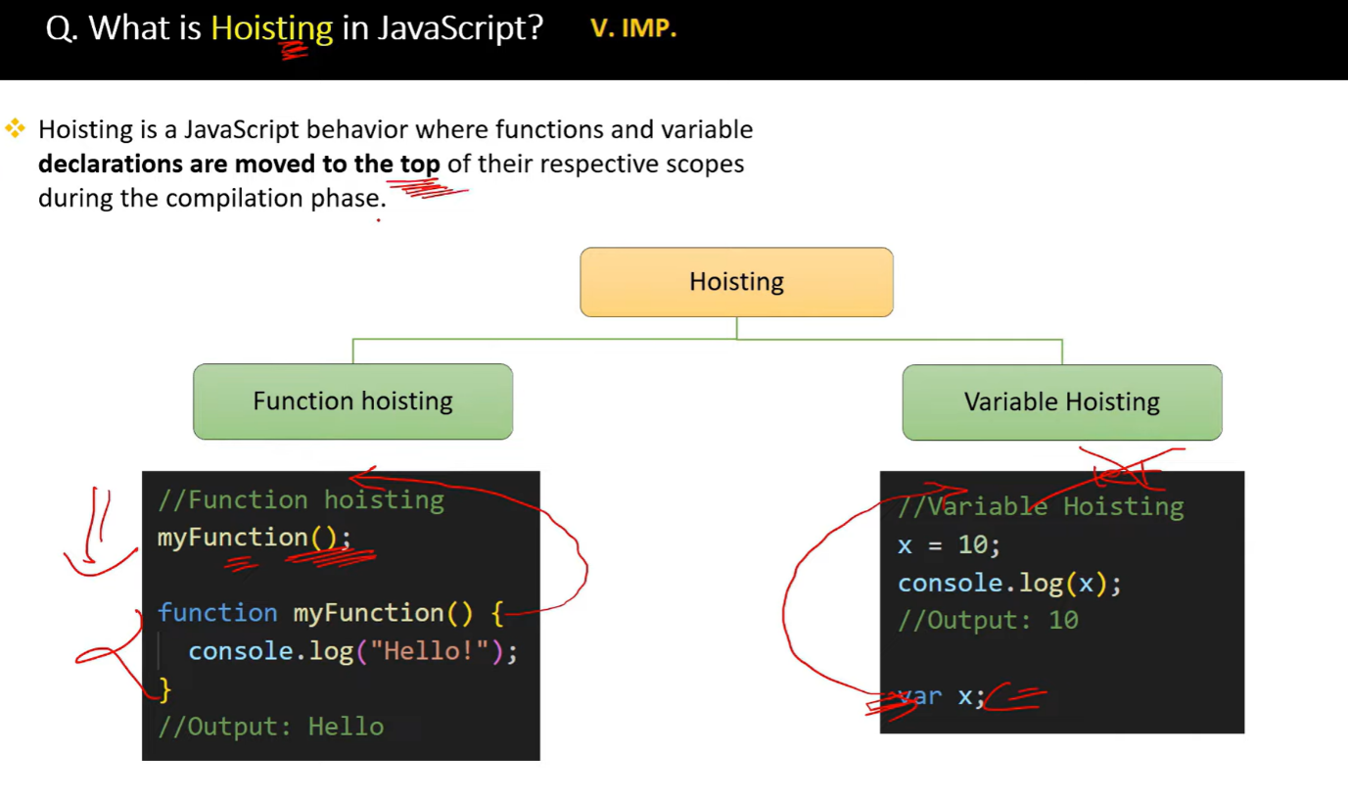

//===================Hoisting========================

function test() {

    console.log(a); // undeined

    console.log(b);  // not defined (temperial dead zone)

    console.log(c);  // not defined (temperial dead zone)

    var a = 6;

    let b = 7;

    const c = 9;

    }

    test();

//    Temporal Dead Zone refers to the period in the execution

    // of a JavaScript program where a variable exists but cannot be accessed.

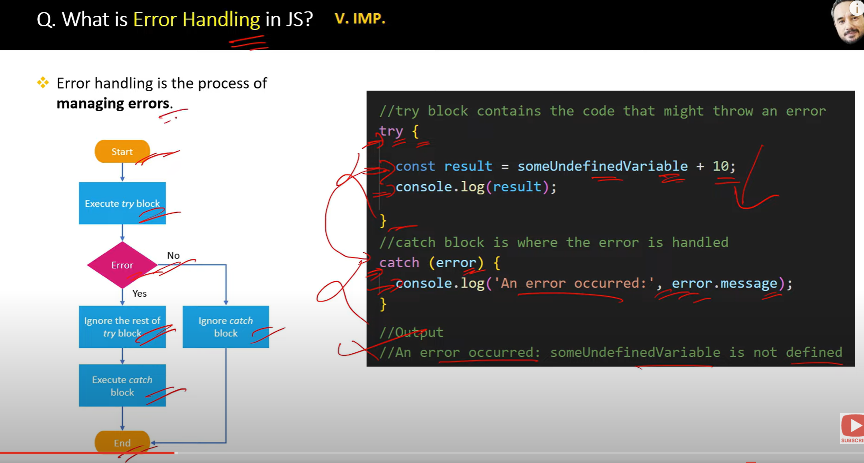

Call method

**The call() method invokes a function immediately and allows you to specify the this value and pass individual arguments to the function.(obj,arg1,arg2,….)**

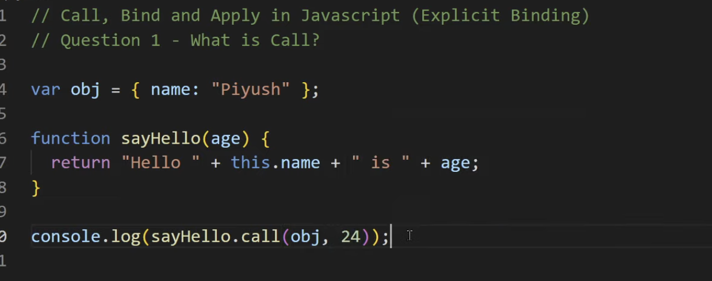

Apply

he apply() method is similar to call(), but instead of passing arguments individually, you pass them as an **array**. It also invokes the function immediately.

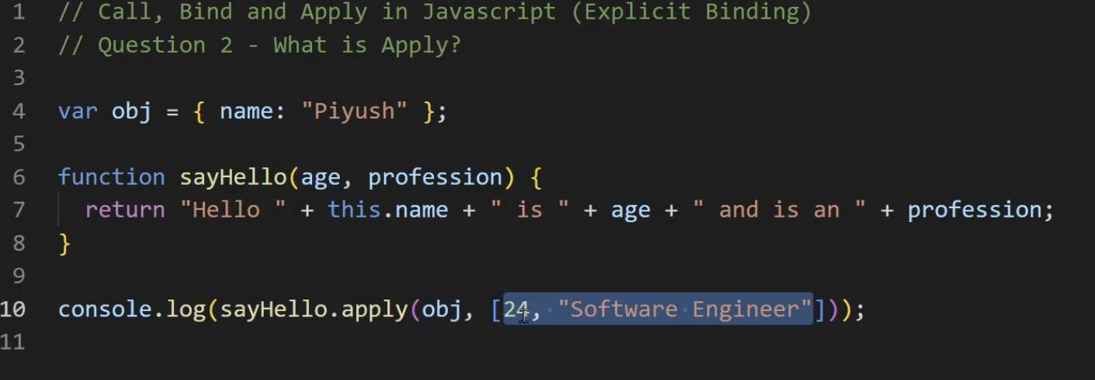

Bind (Resuable function) which in return another function

The bind() method does **not invoke the function immediately**. Instead, it returns a **new function** with a specific this value and (optionally) initial arguments, which can be invoked later.

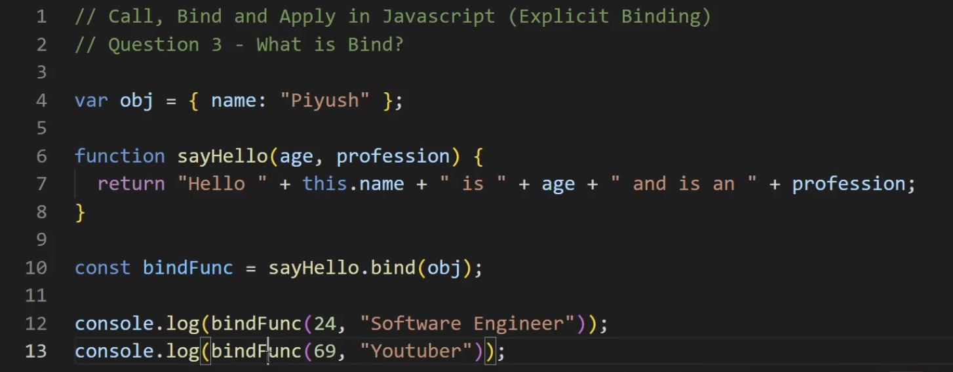

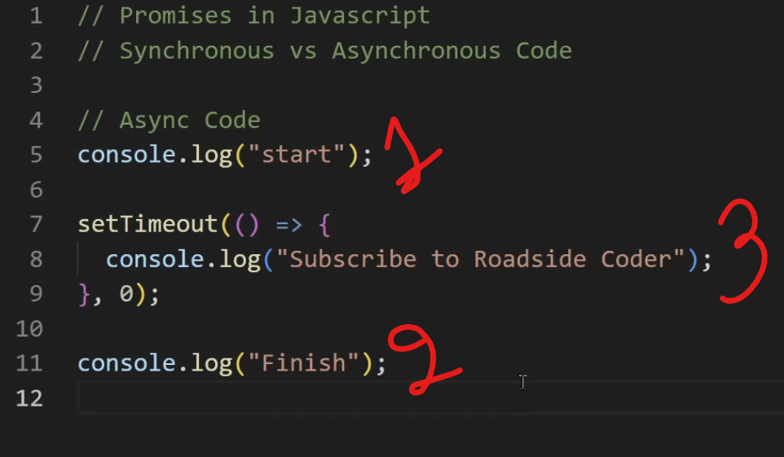

Callback hell nested callback

**Callback hell** refers to a situation in JavaScript (and other programming languages that use callbacks) where multiple nested callbacks lead to code that is difficult to read, maintain, and debug. It typically occurs in asynchronous programming when callbacks are used extensively, resulting in deeply nested structures that resemble a pyramid or "Christmas tree."

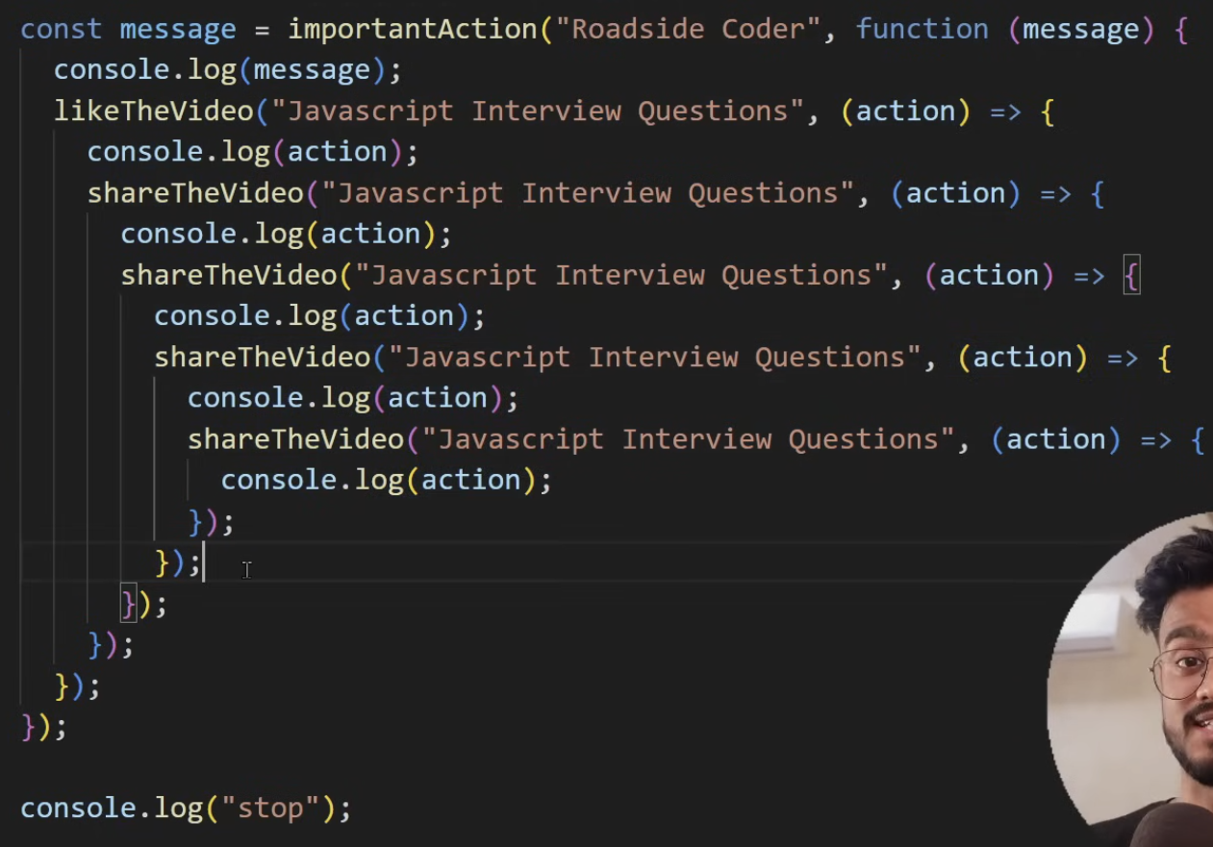

1. **Promises**: Use promises to handle asynchronous operations more cleanly, allowing for chaining and better error handling.

javascript

Copy code

getData()

.then(processData)

.then(saveData)

.then(sendConfirmation)

.then(() => console.log("Operation completed"))

.catch(error => console.error("Error:", error));

1. **Async/Await**: Use async/await syntax for a more synchronous style of writing asynchronous code, which enhances readability.

javascript

Copy code

async function performOperations() {

try {

const data = await getData();

const processedData = await processData(data);

const savedData = await saveData(processedData);

await sendConfirmation(savedData);

console.log("Operation completed");

} catch (error) {

console.error("Error:", error);

}

}

**Summary:**

* **Callback hell** makes code complex and difficult to manage due to excessive nesting of callbacks.
* Solutions include using modular functions, promises, or the async/await syntax to improve readability and maintainability.

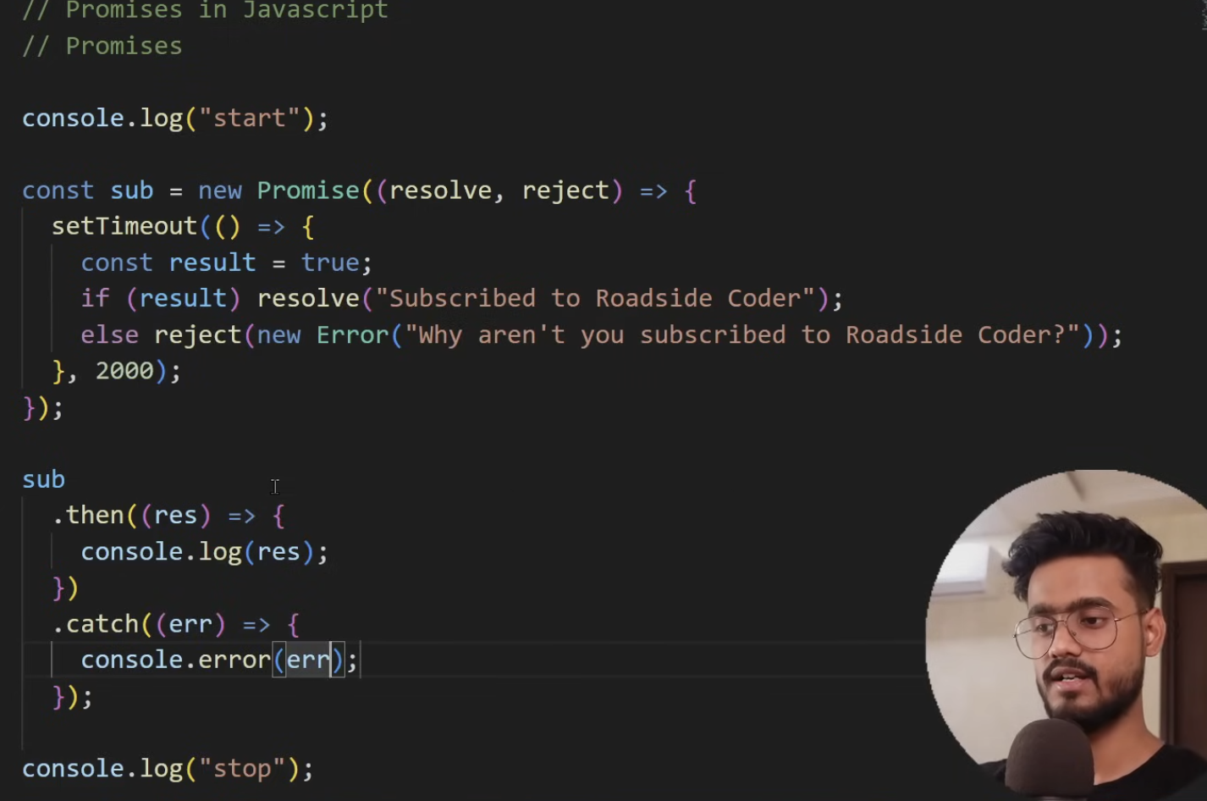

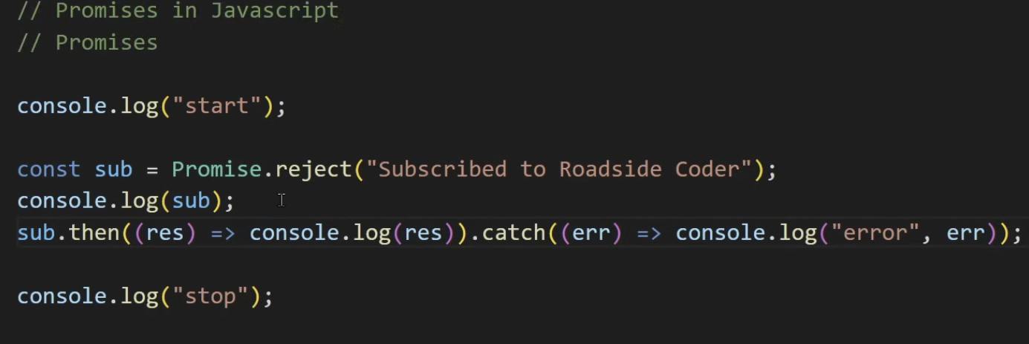

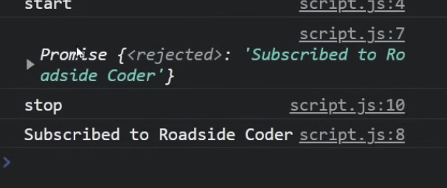

Promise.All => all should be reselved if one fails it wont execute

Promise.Race => Give any first promise resolved or failed

Pomise.allSettled => return fulled with rejected inside resolved

Promise.any => first fulfilled promise and ignores all rejected ones

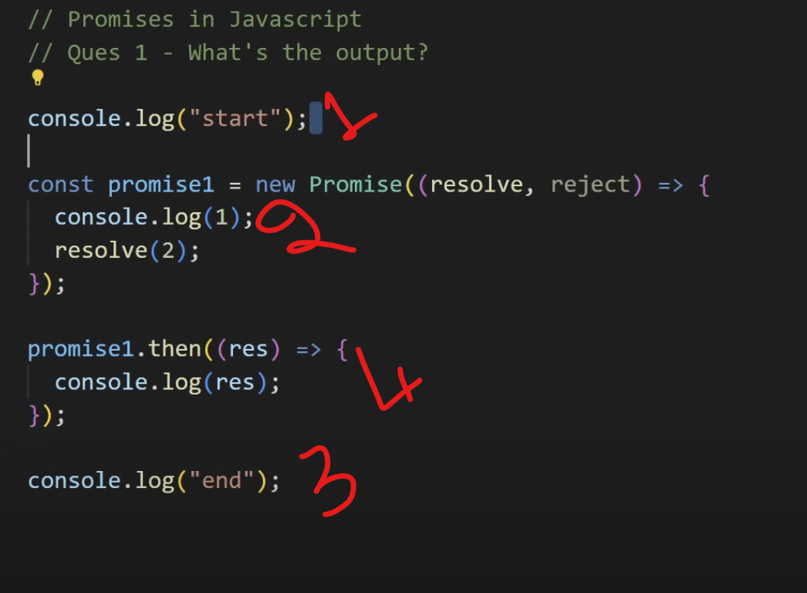

Debouncing =>It limit the execution of function call and waits for certain amount of time to running it again.

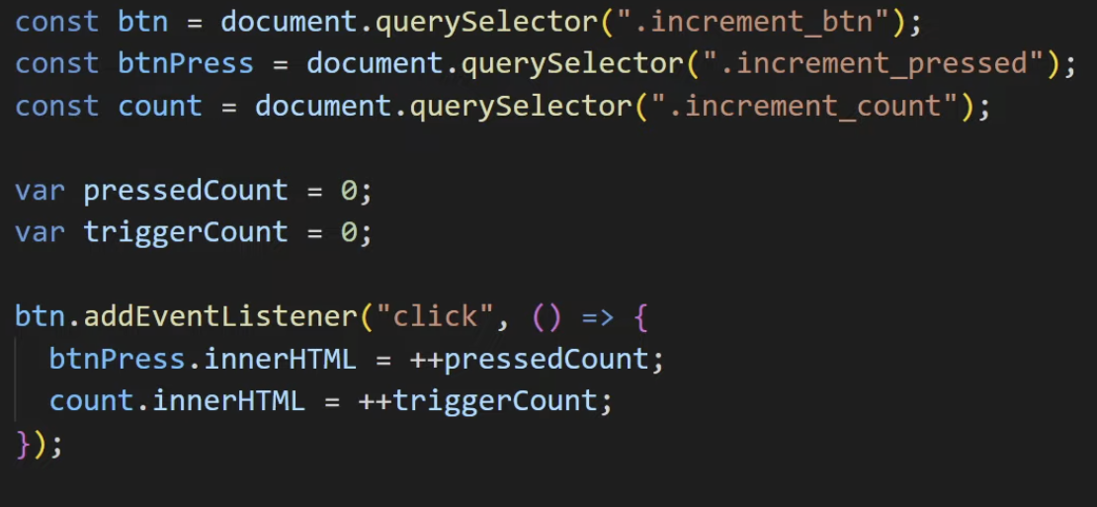

Throttling => It is the technique to limit the excecution of an event handler function even when this event triggers continuously.

When you keep on clicking at add triggers in every 800 ms

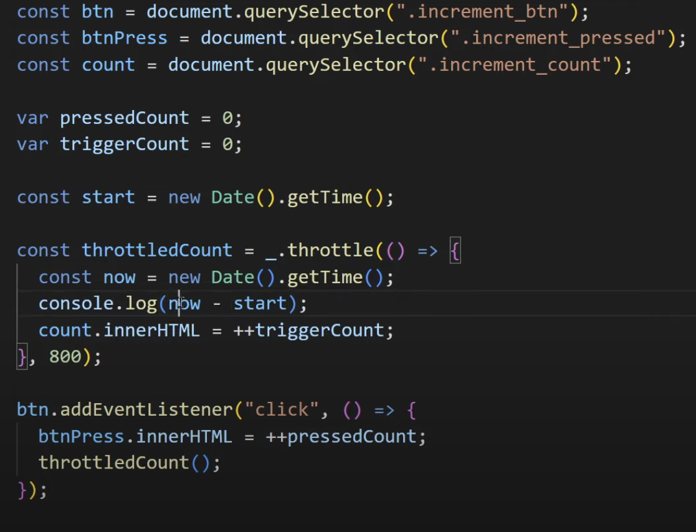

Event Bubling and event capturing  
  
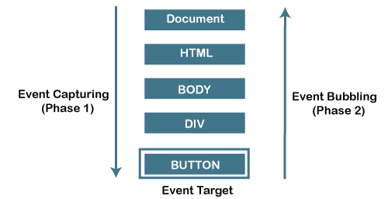

**Event bubbling** is a mechanism in JavaScript where an event starts from the **target element** and then propagates (or "bubbles up") to its **parent elements**. This continues until the event reaches the **document**.

**Key Points:**

* **Event propagation** goes from child to parent.
* Used for **event delegation** (handling events on parent elements for child elements).
* Can be stopped with event.stopPropagation().

**Example:**

**javascript**

**Copy code**

**document.getElementById('parent').addEventListener('click', () => {**

**console.log("Parent clicked");**

**});**

**document.getElementById('child').addEventListener('click', (event) => {**

**console.log("Child clicked");**

**});**

Clicking the child triggers both the child and parent events.

**Event capturing** (or "trickling") is the opposite of event bubbling in JavaScript. In event capturing, the event starts from the **root of the DOM** (like the document or window) and travels down to the **target element** where the event occurs.

**Key Points:**

* **Propagation Direction**: The event goes from the outermost element to the target element.
* Less commonly used than event bubbling, but still useful in certain scenarios.

**Example:**

javascript

Copy code

document.getElementById('parent').addEventListener('click', () => {

console.log("Parent clicked");

}, true); // Capture phase

document.getElementById('child').addEventListener('click', () => {

console.log("Child clicked");

}, true); // Capture phase

**Behavior:**

When you click on the child element:

1. The event first triggers the parent's handler.
2. Then it triggers the child's handler.